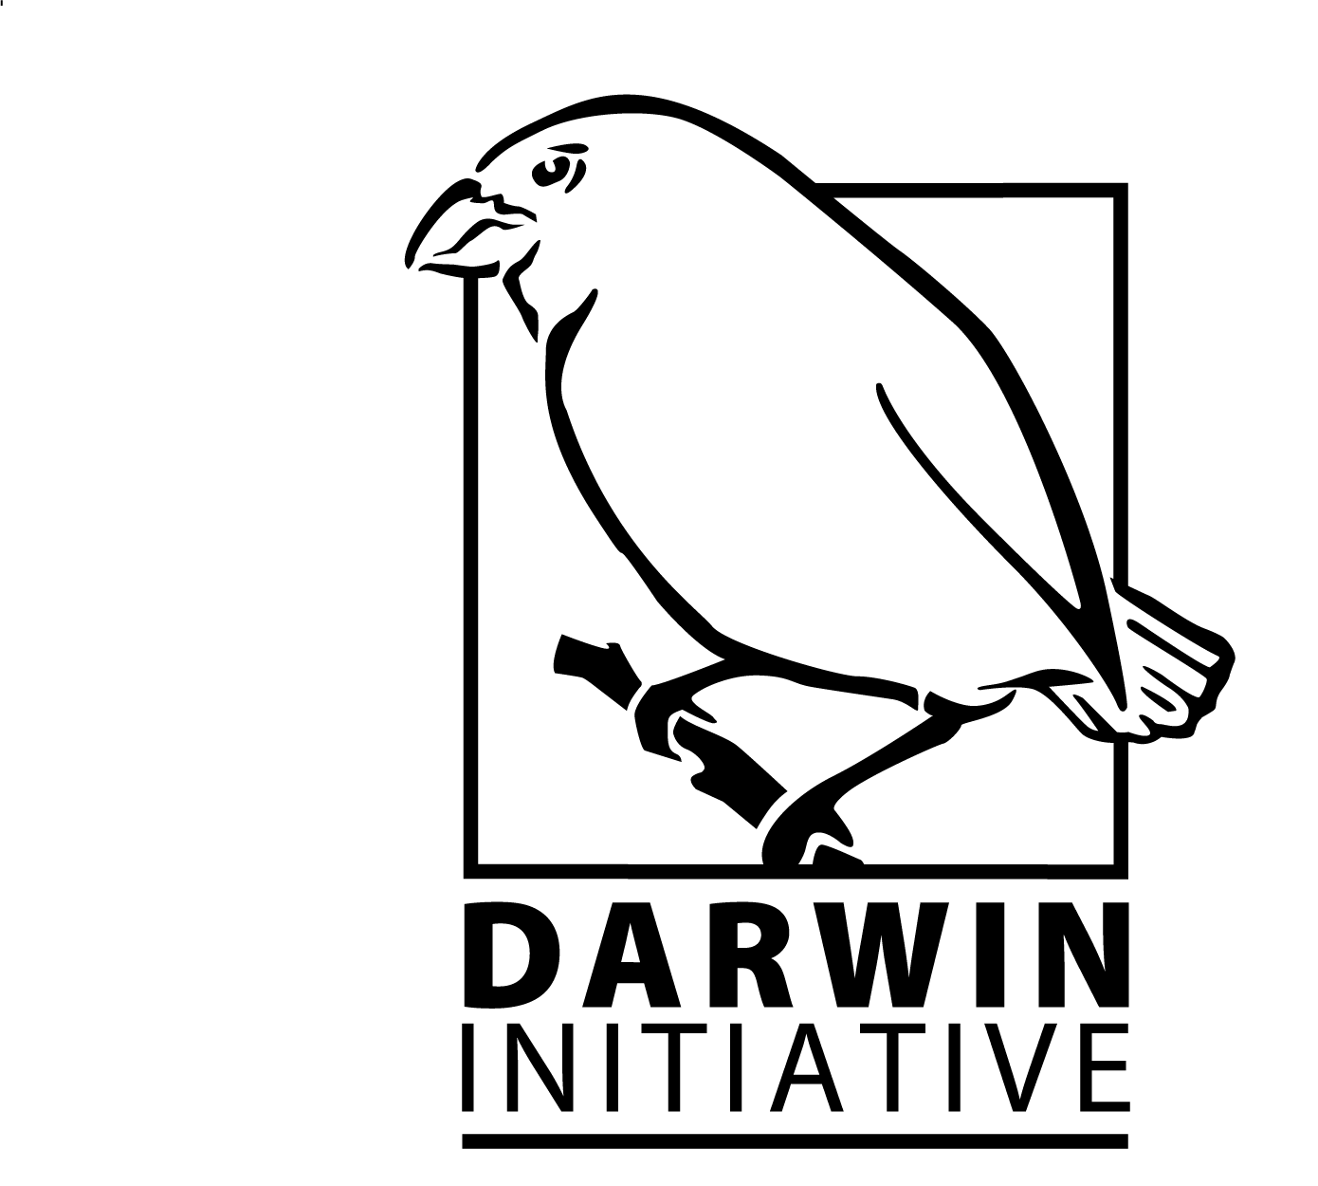
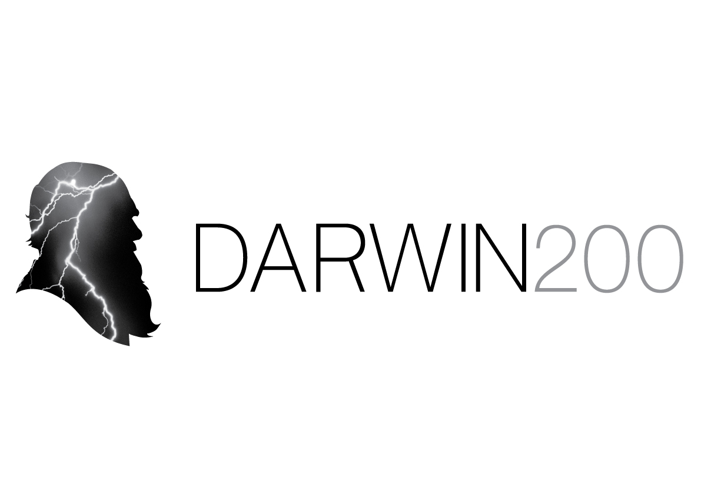

Submit by Monday 20 June 2011

DARWIN INITIATIVE APPLICATION FOR GRANT For Round 18: STAGE 1
Please read the Guidance Notes before completing this form.

Name, postal address and contact details of UK project leader and applicant organisation: (notification of results will be by post)

E-mail address: Phone:
Project title (not exceeding 10 words):

Proposed start date: Duration of project: End date:
Darwin funding requested  (FY Apr – Mar) | 2011/12  £ | 2012/13  £ | 2013/14  £ |  |  | 2014/15  £ |  | 2015/16  £ | Total  £
What matched funding arrangements are proposed?

Indicative matched funding as % of full project cost:
Have you ever applied for Yes  Scoping funding for this No  Project before? |  |  |  | Year of Scoping application: |  |  | Was your Yes If yes,  application attach report  successful? No to this form
Is this a resubmission of Yes  a previously unsuccessful No  Application? |  |  |  | Year and Stage of application: |  |  | Application number if known:
Host country/ies: |  |  |  |  | Other collaborating country/ies
Project Purpose (extracted from logframe):

No. of people to be employed on the project from host country/ies (more than 10% of their time): |  |  |  |  | No. of people to be employed by the project in the UK (more than 10% of their time on the project):
List the partner organisations and briefly outline their involvement in the project to date: (Max 150 words)

Concept note (maximum 1,000 words). Describe the problem to be addressed, explain why it is a priority for the host country and how its resolution will improve host country ability to meet its obligations under CBD/CMS/CITES and how the project will benefit local communities. The proposed strategy and its intended outcomes should be described adequately, including justification for and brief details of the contribution of each partner.

LOGICAL FRAMEWORK

Please enter details of your project onto the matrix below using the note at Annex 3 of the Guidance Notes. Do not extend past 2 pages.
NB: Project Activities detail not necessary at this stage.
Project summary | Measurable Indicators | Means of verification | Important Assumptions
Goal:
Effective contribution in support of the implementation of the objectives of the Convention on Biological Diversity (CBD), the Convention on Trade in Endangered Species (CITES), and the Convention on the Conservation of Migratory Species (CMS), as well as related targets set by countries rich in biodiversity but constrained in resources.
Sub-Goal:

Purpose

Outputs (add or delete rows as necessary)
1.

2.

3.

4.

Legacy and Sustainability: What steps will be taken to ensure that project outputs and outcomes are sustainable, involve local communities and will be effective in assisting the recipient country to strengthen its biodiversity and/or meet international commitments under CBD/CITES/CMS? (max 250 words)

I certify that, to the best of our knowledge and belief, the statements made in this application are true and the information provided is correct.

Name (block capitals):

Position in organisation:

Signed:

Dated:

Stage 1 Application - Checklist for submission

Check
Have you provided actual start and end dates for your project?
Have you provided your budget based on UK government financial years ie 1 April – 31 March? NB: we do not require the budget spreadsheet at this stage.
Is the concept note within 1,000 words?
Is the logframe no longer than 2 pages?
Has your application been signed by a suitably authorised individual? (clear electronic or scanned signatures are acceptable in the email, but a wet signature should be provided in the hard copy version)
Have you read the Guidance Notes?
If you received a relevant Scoping Award, have you included the report with this application?
Have you checked the Darwin website immediately prior to submission to ensure there are no late updates?
Do not include letters of support or CVs with this application.

Once you have answered Yes to the questions above, please submit the application in Word format, not later than midnight GMT on Monday 20 June 2011 to
Darwin-Applications@ltsi.co.uk using the title of the project (or first few words) as the subject of your email.

Please also send a hard copy of your application to the Darwin Applications Management Unit, c/o LTS International, Pentlands Science Park, Bush Loan, Penicuik EH26 0PL. Although a hard copy is required APPLICATIONS WILL BE ASSESSED AGAINST THE ELECTRONIC VERSION SUBMITTED.

DATA PROTECTION ACT 1998: Applicants must agree to any disclosure or exchange of information supplied on the application form (including the content of a declaration or undertaking) which the Department considers necessary for the administration, evaluation, monitoring and publicising of the Darwin Initiative. Application form data will also be held by contractors dealing with Darwin Initiative monitoring and evaluation. It is the responsibility of applicants to ensure that personal data can be supplied to the Department for the uses described in this paragraph. A completed application form will be taken as an agreement by the applicant and the grant/award recipient also to the following:- putting certain details (ie name, contact details and location of project work) on the Darwin Initiative and Defra websites (details relating to financial awards will not be put on the websites if requested in writing by the grant/award recipient); using personal data for the Darwin Initiative postal circulation list; and sending data to Foreign and Commonwealth Office posts outside the United Kingdom, including posts outside the European Economic Area. Confidential information relating to the project or its results and any personal data may be released on request, including under the Environmental Information Regulations, the code of Practice on Access to Government Information and the Freedom of Information Act 2000

