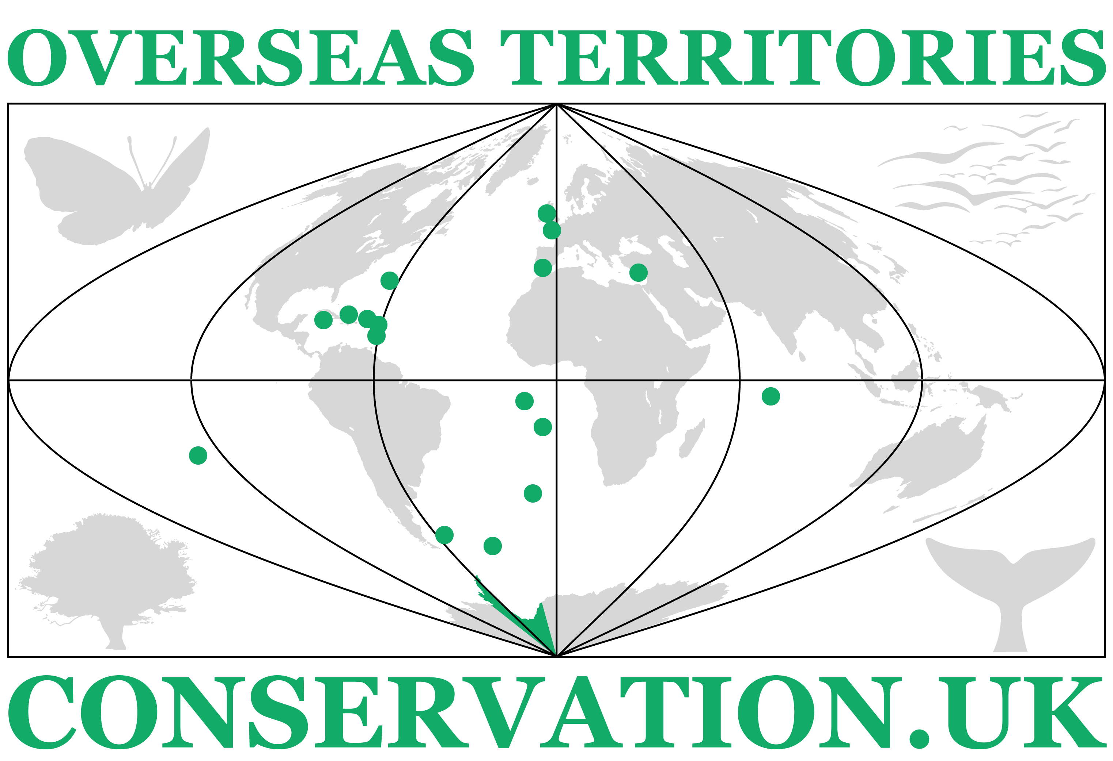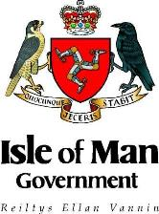
Issued: Monday 12th February 2018
NEWS RELEASE
Good progress on issues of common interest at meeting of Environment Ministers from the UK’s Overseas Territories and Crown Dependencies
Ministers and senior officials from UK Overseas Territories (OTs) and Crown Dependencies (CDs) travelled to the Isle of Man last week to discuss the future of the environment in their jurisdictions.
This was the third Council of Environment Ministers of UK Overseas Territories and Crown Dependencies and took place in Douglas, on 6th and 7th February. Previous meetings took place in Gibraltar in 2015 and continued in Alderney in 2017.
The meeting was hosted jointly by Geoffrey Boot MHK, the Isle of Man’s Minister for Environment, Food and Agriculture, and Professor John Cortés, Gibraltar’s Minister for Education, Heritage, Environment, Energy and Climate Change and co-ordinated by the UK Overseas Territories Conservation Forum (UKOTCF), a non-governmental organisation.
The agenda for the meeting focussed on sustainability in the terrestrial and marine environment, climate change, the impact of natural disasters on communities, environmental resilience and the Isle of Man’s designation as the first entire nation UNESCO Biosphere Reserve.
Common opportunities and challenges were discussed on issues such as the role of the environment in growing the economy, energy efficiency, sympathetic development, enforcement and the impact of plastics.
Delegates also discussed the opportunities resulting from, and challenges posed by, the withdrawal of the UK from the European Union.
Minister Boot said: ‘Although very different in character, our islands all boast beautiful environments that are important to our economies and our way of life and that we wish to retain and maximise the benefit from.
‘The meeting was an excellent opportunity to share good practice and discuss common concerns and we learned a lot from meeting that we can put into effect in our islands.
‘It was especially useful to discuss with the UK’s Environment Minister, Dr Thérèse Coffey, how our jurisdictions can work together, and more closely with the UK, to ensure a coherent approach on matters such a plastic waste, ocean acidification and warming. Minister Coffey invited the group to join the UK’s discussions on these matters.’
Professor Cortes said: ‘The way our diverse territories work together in mutual support and for the protection and improvement of the environment and quality of life is our main strength and an example to others.
‘We are looking at a sustainable future within our territories but have also recognised our responsibility beyond our shores. Most of us are islands and so we are also championing the future of our oceans by joining the stand against plastic pollution and working towards improvement of the biological status of the many kilometres of sea that are the responsibility of the United Kingdom.’
Hon. David Osborne, Montserrat’s Minister for Agriculture, Trade, Lands, Housing and Environment, said: ‘By working as a group, we are much stronger in being able to achieve certain goals. Many of us are facing similar problems and, because of Brexit, much uncertainty remains. However, if we come together we can put forward ideas for ways to overcome these challenges, much can be achieved.’
Dr Mike Pienkowski, Chairman of UKOTCF, commented ‘We have for over 30 years brought together groups of practitioners, decision makers and civil society across the Overseas Territories and Crown Dependencies to share experiences and encouraged collective endeavour. This is now more relevant than ever, given the unique set of challenges faced by them especially in the face of climate change and some of the consequences of the UK’s departure from the European Union. The meeting heard about the work of the Department of Environment, Food and Agriculture to meet its international commitments and to support its fishing communities, which is huge interest to other jurisdictions.’
Ministers and representatives of the Falkland Islands, Pitcairn and St Helena, joined the meeting via Skype or other remote means.
A post-meeting statement charting the progress made will be agreed by delegates and published.
Following the formal business, Minister Boot escorted Ministers on an excursion to Tynwald, Milntown in Ramsey and the Department of Environment, Food and Agriculture’s headquarters in St John’s, giving them the opportunity to see the Island.
Ends
For further information, please contact:
Geoffrey Boot MHK, Minister for Environment, Food and Agriculture, Isle of Man – +44(0) 7624 381497
Dr Mike Pienkowski, UKOTCF Chairman – +44(0) 777 8841 233
List of Ministers and other lead representatives attending
Hon. Geoffrey Boot MHK, Minister for Environment, Food and Agriculture (Host and co-Chairperson of Meeting), Isle of Man
Prof. John Cortés , Minister for Education, Heritage, Environment, Energy & Climate Change, Gibraltar
Mr James Dent, Chairman, Policy and Finance Committee, States of Alderney
Mr Paul Veron, Strategic Adviser, States of Alderney and Guernsey
Deputy Steven Luce, Minister for the Environment, Jersey
Dr Richard Axton , Chairman of Council, La Société Sercquaise, on behalf of Sark Agriculture and Environment Committee of the Chief Pleas [Administration] of Sark
Hon. Walton Brown, JP, MP Minister of Home Affairs [including Environment], Bermuda
Hon. David Osborne, Minister for Agriculture, Trade, Lands, Housing & Environment, Montserrat
Mr James Glass, Councillor and Director of Fisheries, Tristan da Cunha
Mr Jim Kerr, Deputy UK Representative, Tristan da Cunha
Hon. Ralph Higgs, Minister of Tourism, Environment, Culture, Heritage & Gaming, Turks & Caicos Islands
Participating via Skype or other remote means:
MLA Teslyn Barkman, Portfolio Holder for the Environment, Falkland Islands
Mrs Michele Christian, Councillor and Divisional Manager Environmental Conservation & Natural Resources, Pitcairn
Mr Russell Yon, Chairman of Environment & Natural Resources Committee, St Helena
Word count: 661
Notes for newsdesks:
Attached are photos of the meeting at the Villa Marina and delegates being show around the Island of Man.

